A Study on Data Communication Generations

<1:A.Usha > , <2:A.Murali Mohan Kumar>

1. Student, MCA, Mother Theresa Institute of Computer Application, Palamaner.
2. Associate Professor, Head of Department MCA, Mother Theresa Institute of Computer

Application, Palamaner.

<aaushasree@gmail.com> , <Muralimohan@mtimca.edu.in>

Abstract:

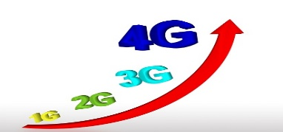 Data Communication, the exchange of data between devices, is a fundamental aspect of modern technology, evolving through generations like 1G, 2G, 3G, 4G and 5G, each offering advancements in speed, capacity and capabilities. Data communication means is the process of transferring data between two or more devices over a transmission medium. The effectiveness of data communication System depends on Delivery, Accuracy, and Timeliness.

**Keywords:**

Sender, Receiver, Message, Transmission Medium, Protocol

**First Generation (1G):**

1G (First Generation) Data Communication refers to the earliest era of wireless communication, introduced in the 1980s, characterized by analog signal transmission primarily for voice communication. It marked the beginning of mobile technology, allowing people to make calls without being tethered to a fixed line. The technology used in 1G networks was based on analog radio signals, offering limited capacity, poor voice quality, and no support for data services like text messaging or internet access. The most notable 1G technology was the Advanced Mobile Phone System (AMPS), which was widely used in the United States.

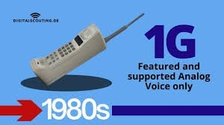

**Second Generation (2G):**

2G (Second Generation) Data Communication marked a significant shift from analog to digital technology, introduced in the 1990s. This generation enabled digital voice transmission, improving call quality, security, and network efficiency compared to 1G. It also introduced basic data services like SMS (Short Message Service) and MMS (Multimedia Messaging Service), allowing users to send text messages and multimedia content. Key technologies of 2G included GSM (Global System for MobileCommunications), CDMA (Code Division Multiple Access), and GPRS (General Packet Radio Service), which provided basic mobile internet access.

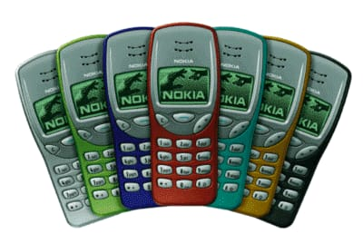

**Third Generation (3G):**

3G (Third Generation) Data Communication revolutionized mobile technology in the early 2000s by introducing high-speed wireless internet and advanced multimedia capabilities. Unlike its predecessors, 3G supported faster data transmission, enabling activities like video calling, mobile internet browsing, and streaming services. It relied on technologies such as UMTS (Universal Mobile TelecommunicationsSystem) and CDMA2000, which provided better coverage and higher data rates. 3G networks offered speeds ranging from 384 kbps to 2 Mbps, supporting applications like mobile gaming, GPS navigation, and mobile banking. This generation played a crucial role in the development of smartphones and the expansion of mobile broadband services worldwide.

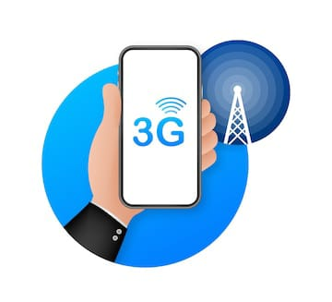

**Fourth Generation (4G):**

4G (Fourth Generation) Data Communication marked a major leap in wireless technology, offering significantly faster internet speeds, low latency, and enhanced network performance compared to previous generations. Introduced in the late 2000s, 4G networks are based on IP (Internet Protocol)-based architecture, supporting seamless data transmission for high-definition video streaming, online gaming, and real-time communication. Technologies like LTE (Long-Term Evolution) and WiMAX were key to 4G's success, providing download speeds up to 1 Gbps and upload speeds up to 100 Mbps under ideal conditions. This generation enabled the rise of smartphones, mobile apps, and services like VoIP and HD video conferencing, transforming how people access and share information globally.

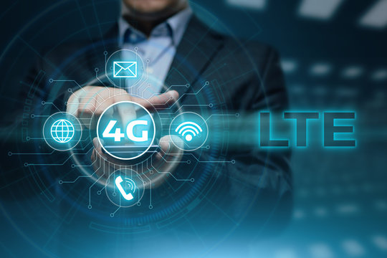

**Fifth Generation (5G):**

5G (Fifth Generation) Data Communication is the latest advancement in wireless technology, offering ultra-fast speeds, ultra-low latency, and massive connectivity to support the growing demands of modern digital ecosystems. Launched in the late 2010s, 5G operates on advanced technologies like Millimeter Waves (mmWave), Massive MIMO, and Network Slicing, providing speeds up to 10 Gbps and latency as low as 1 millisecond. It enables seamless experiences in applications such as IoT (Internet of Things), autonomous vehicles, smart cities, augmented reality, and real-time remote control of devices. 5G also supports high-density connections, making it ideal for environments with numerous connected devices, transforming industries like healthcare, entertainment, and transportation.

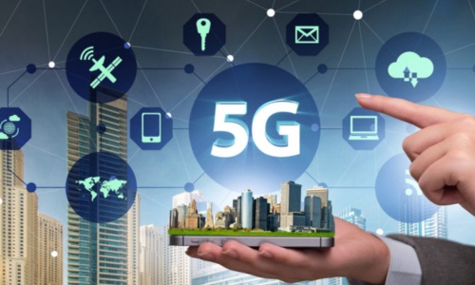

**Upcoming Generation (6G/7G):**

6G (Sixth Generation) Data Communication is the next evolution in wireless technology, expected to launch around the 2030s, offering terabit-per-second (Tbps) speeds, ultra-low latency, and advanced network efficiency. It will leverage technologies like terahertz (THz) frequencies, AI-driven networks, and holographic communication to enable immersive experiences in AR, VR, and real-time global connectivity. 6G will also support ultra-dense IoT environments and advanced automation across industries. Looking beyond, 7G (Seventh Generation) remains a conceptual idea, potentially focusing on quantum communication and interplanetary networking for space-based applications. While 6G aims to revolutionize Earth-based connectivity, 7G could redefine communication on a cosmic scale.

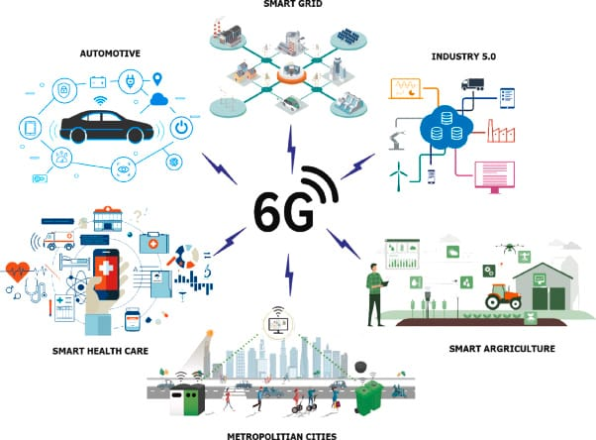

**CONCLUSION :**

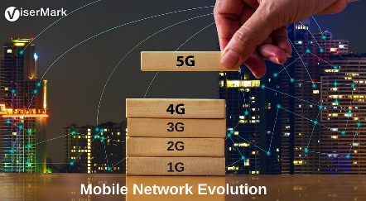

The timeline and history from 1G to 5G took just over 40 years since the introduction of wireless cellular technology. And a lot has changed since then.

* Cell phones have become smaller.
* Download speeds have become faster.
* Text messaging has come ([and almost gone](https://www.statista.com/chart/12109/sms-volume-in-the-united-states/)).
* Surfing the internet with phones became common.
* The steam of social media posting continues.
* And apparently, there’s an app for nearly everything now.

The timeline from 1G to 5G couldn’t have happened without creating and enhancing each generation of telecommunications leading to what it is today. Roughly every ten years since 1979, each newer generation has changed how we communicate, further improving our way of life.

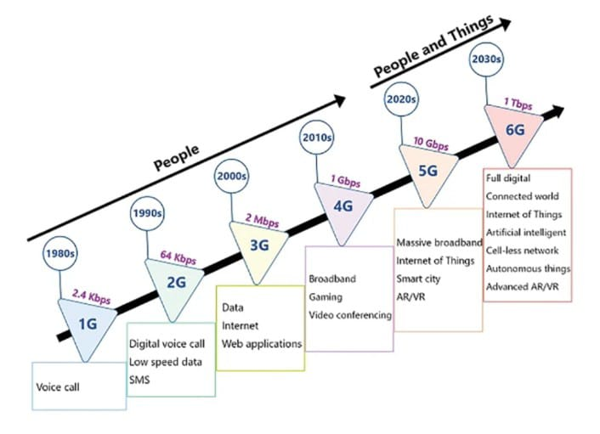

**EVOLUTION OF CELLULAR NETWORKS**